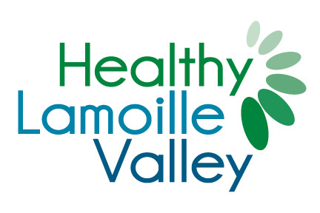

**Funding Opportunity**

The design of our community and the environment that surrounds us affects both our physical and mental health and has an influence over the choices we make every day. Whether or not people are physically active or eat healthy can often be determined by what they have access to. When communities provide access to healthy foods and safe places to recreate and play, they are creating an environment that makes it easier for people to live healthy, active lives.

Healthy Lamoille Valley is working within municipalities in Lamoille County to identify opportunities to increase local infrastructure and access to biking, walking, outdoor recreation, local farms and food and community gardening. Applications are now being accepted for community-based projects in the following areas:

***Increasing Access to Healthy Foods***

* Community Garden Projects and Infrastructure
* Operational Support for Farmer’s Markets – signs, EBT machines

***Create or Improve Local Parks and Recreation Areas***

* Lighting
* Trees
* Benches
* Signage
* Courts
* Playing Fields
* Community Pools
* Skate Parks
* Community Playgrounds

***Bike and Pedestrian Improvements***

* Signs and Markings
* Bike racks
* Landscaping
* Streetscape Improvements
* Walking/Biking Maps
* Trail Maintenance/Development

***Promoting Healthy Lifestyles***

* Healthy Cooking Classes
* Home Gardening Workshops
* Community-Based Health and Wellness Programs
* Group Fitness Classes (to offer free group exercise classes).
* Sports/recreational equipment made available to residents through community share programs (i.e. bikes, snowshoes, skis).

**Priority will be given to projects that:**

1. Are community-based reaching the broadest number of people.
2. Demonstrate a community need.

**Funding will be offered to the following entities:**

* Municipalities
* Non-profit 501c3 organizations
* Schools
* Fitness Facilities and/or Fitness Instructors (to offer free group exercise classes).
* Health Care Organizations
* Civic Groups

**If you have questions please contact Kate at 279-1869**

**Please email completed applications to:** [**kate@healthylamoillevalley.org**](mailto:kate@healthylamoillevalley.org)

**Additional Information:**

The Healthy Lamoille Valley steering committee will review all applications submitted. A response can be expected by January 30, 2015. Proposed projects should be completed by September 2015. Thank you for helping to create a healthy community!